Pretraining Signals in Multimodal AI
Goal of this Module
The goal of this module is to explain the key pretraining techniques (signals) that build strong multimodal foundations, like teaching an AI "baby" the world through picture books. You'll learn four main signals (contrastive, captioning, masked modeling, multi-task), plus fine-tuning strategies (LoRA/adapters, preference tuning), data curation tips, and evaluation pitfalls. By the end, you'll understand:

How pretraining creates aligned, transferable representations for tasks like fashion matching
Practical ways to adapt pretrained models efficiently
Common traps like hallucinations and how to mitigate them
This equips you to build or refine multimodal systems (e.g., saree styling app) with high-quality, grounded outputs.

Pretraining is like giving your AI baby millions of picture books so it learns the world before school starts. Four big signals people use (often mixed together):
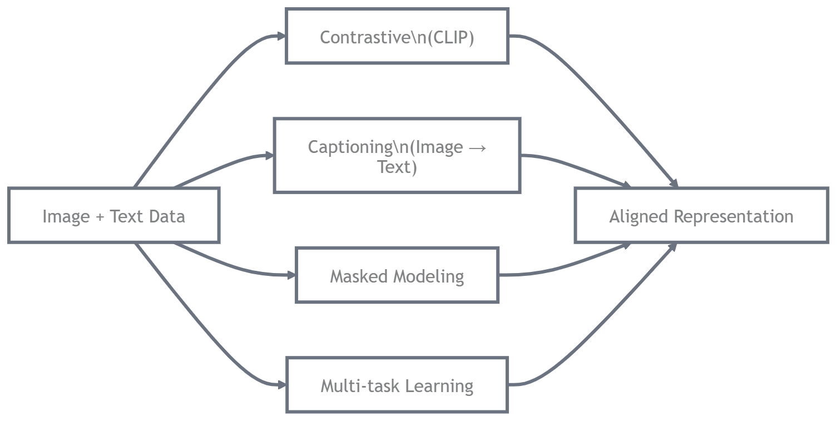

Contrastive (CLIP-style)
Contrastive (CLIP-style): "This photo matches this caption; all others don't." Pulls matching pairs close in embedding space, pushes mismatches away. It's the king for alignment and zero-shot magic.
Here’s the classic CLIP contrastive diagram look how one good pair gets highlighted while the rest get dimmed:
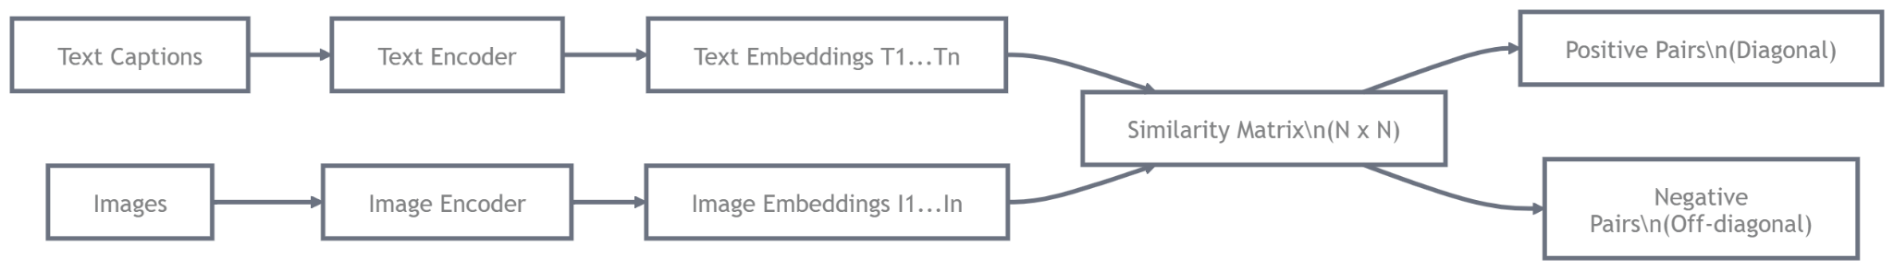
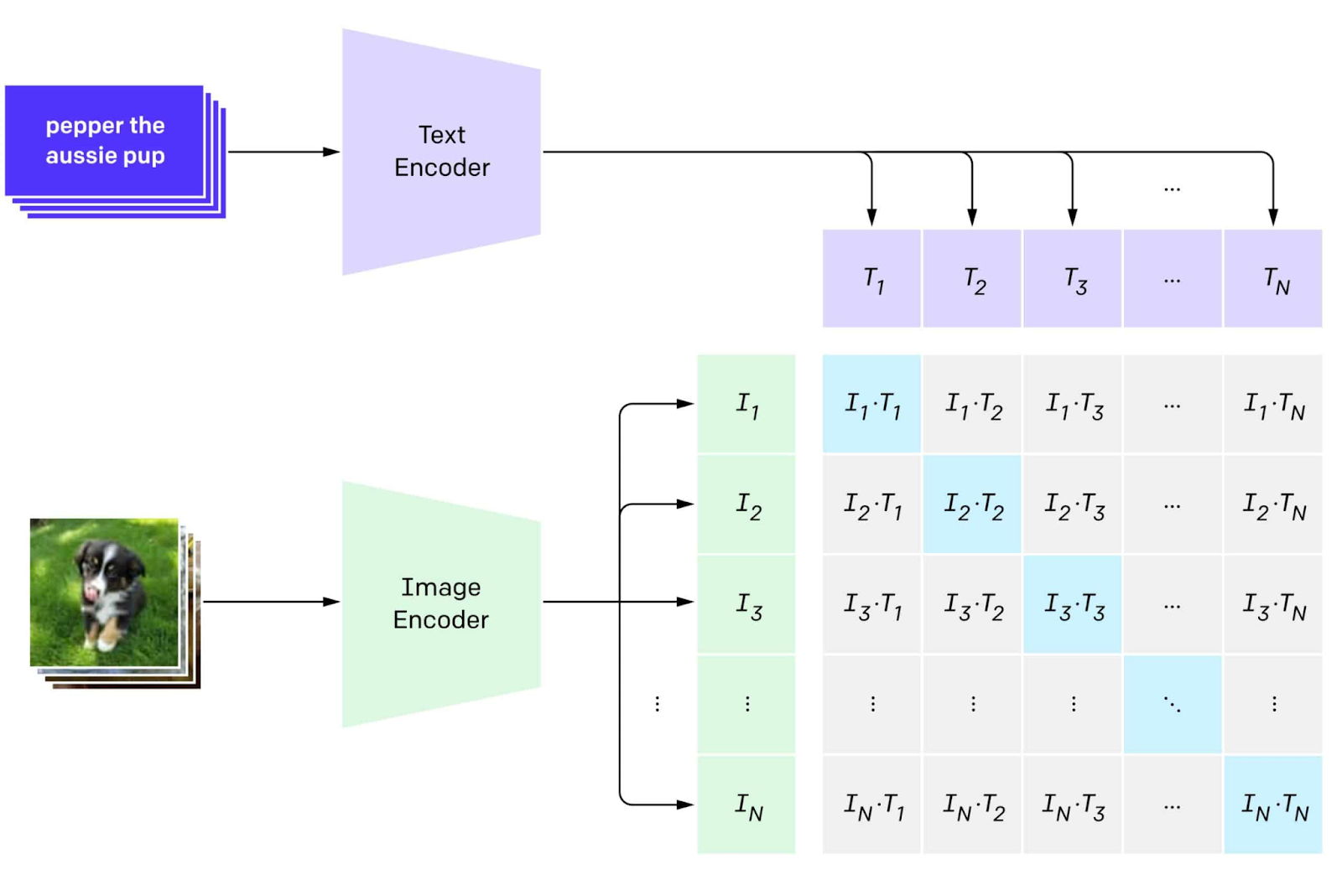

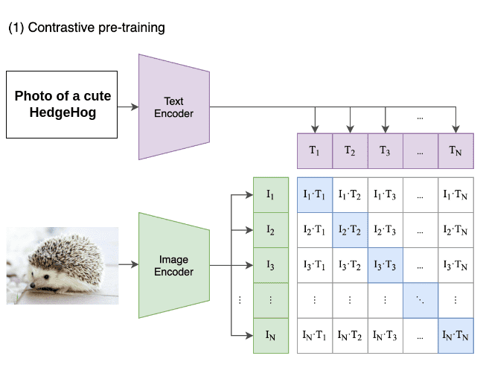

CLIP doesn't try to generate captions or answer questions at first. Instead, it learns by playing a massive "matching game":
- It sees millions of image + caption pairs scraped from the internet.
- For each batch of pairs, it says: "This photo truly belongs with this caption (positive pair). All the other 31,999 captions in the batch do NOT belong with this photo (negatives)."
- The model gets rewarded when it makes the correct match stand out and pushes wrong matches away.
The diagram is showing exactly this setup twice (left side for one example, right side for another), so you see the pattern repeating.

Key Parts of the Diagram Explained Step by Step

Input Side (Left = Text stacks, Right = Images)
  - On the left: A stack of text captions ("pepper the aussie pup", etc.) → goes into the Text Encoder.
  - On the right: A photo of a cute puppy (or hedgehog in the other half) → goes into the Image Encoder.

These are the two "towers" of CLIP — completely separate neural networks at first:
  - Text Encoder: Usually a Transformer (like a mini GPT) that reads words and turns the whole sentence into one fixed-size vector (embedding).
  - Image Encoder: Usually a Vision Transformer (ViT) that chops the image into patches, processes them, and outputs one vector summarizing the whole picture.

Output: Rows of T₁, T₂, … Tₙ and I₁, I₂, … Iₙ
  - After encoding:
    - Each caption becomes a vector Tᵢ (text embedding).
    - Each image becomes a vector Iⱼ (image embedding).
  - All vectors live in the same shared embedding space (same number of dimensions, e.g. 512 or 768).

The Similarity Matrix (the Grid in the Middle)
  - This is the heart of the diagram — the big table of dots/multiplications.
  - Every Iⱼ · Tᵢ is a similarity score (usually cosine similarity or dot product after normalization).
    - High score = the image and text are pointing in almost the same direction in embedding space → they match well.
    - Low score = they're unrelated or opposite.

In a batch of size N (say N=32 or 128 in practice):
  - You get an N × N grid of similarities.
  - The diagonal (I₁·T₁, I₂·T₂, … Iₙ·Tₙ) are the positive pairs — the real matches from the dataset.
  - Everything off-diagonal is a negative pair — wrong combinations the model should learn to dislike.

In the diagram:
  - The correct match is highlighted / colored brighter (blue-ish in many versions).
  - All the wrong ones are dimmed / faded.

That's the visual way of saying: "Make the bright one even brighter, make the dim ones disappear."

The Two Examples Side-by-Side
  - Left example: Puppy photo matched to "pepper the aussie pup" caption.
  - Right example: Hedgehog photo matched to its own caption.
  - The diagram repeats the same flow to show it's not a one-off — this happens for every image-caption pair in the batch simultaneously.

Few concepts which you know already:
Embedding Space A high-dimensional "map" (usually 512–1024 dimensions) where similar things live close together. Goal: After training, "photo of a golden retriever" text vector should be very close to actual golden retriever photos, and far from cats or cars.
Contrastive Learning Learning by comparison: strengthen positives, weaken negatives. No need for pixel-level labels or perfect captions — just "this goes with that, the rest don't."
InfoNCE Loss (the math under the hood, not shown but implied) For each image, treat its real caption as positive and the other (N-1) as negatives. The loss says: "Make the probability of picking the correct caption (among N choices) as close to 100% as possible." It's symmetric: same thing happens from text side looking at images.
Batch Size Matters Bigger batch = more negatives = stronger learning signal. CLIP famously used batches of 32,768 — that's why it needed huge compute.
Zero-Shot / Transfer Ability (why CLIP became legendary) After this training, you can give brand-new text like "a photo of a doctor wearing PPE" and the model will find matching images without ever seeing that exact phrase during training. The diagram doesn't show inference, but that's the payoff.

In fashion app → contrastive pretraining lets the model instantly match "elegant blue Banarasi silk saree with zari border" to the right photos without any extra training.
- Captioning (image → text generation): Model sees image, predicts a natural description. Forces it to understand details deeply.
- Masked Modeling (like MAE for images or FLAVA): Hide parts of the image (or text), make the model guess what's missing. Great for learning local structure (textures, layouts).
- Multi-task: Do all of the above in one go (contrastive + captioning + masking). Many SOTA models (like Flamingo, PaLI) mix them for stronger representations.
Real-World Example: Instagram's recommendation system uses contrastive learning to match user-uploaded photos with similar content, improving feed personalization.
Code Implementation Example: Simplified InfoNCE loss for contrastive learning in PyTorch.
import torch
import torch.nn.functional as F

def info_nce_loss(features, temperature=0.07):
# Assume features is [2*batch_size, embed_dim] where first half are anchors, second are positives
batch_size = features.shape[0] // 2
anchors = features[:batch_size]
positives = features[batch_size:]

# Normalize
anchors = F.normalize(anchors, dim=1)
positives = F.normalize(positives, dim=1)

# Similarity matrix (batch x batch)
logits = torch.matmul(anchors, positives.T) / temperature

# Labels are diagonal (positive pairs)
labels = torch.arange(batch_size).to(logits.device)

# Symmetric loss
loss = (F.cross_entropy(logits, labels) + F.cross_entropy(logits.T, labels)) / 2
return loss

# Example usage
features = torch.randn(10, 512) # 5 anchors + 5 positives
loss = info_nce_loss(features)
print(loss)

Fine-tuning Strategies
Once pretrained, you adapt it for your use case without retraining everything.
- LoRA / Adapters for Multimodal: Instead of updating the whole huge model (billions of parameters), add tiny trainable "plugins" (low-rank matrices) to key layers. Freeze the base, train only ~1-5% of params.
- 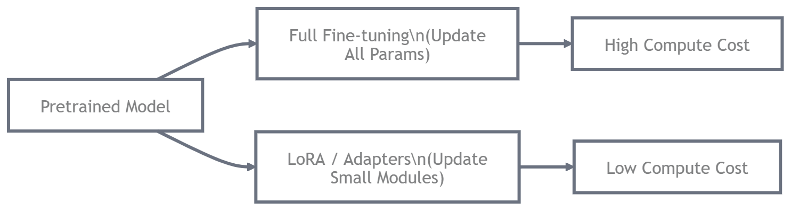
Here are two great visuals, one comparing full fine-tuning vs LoRA (left side scary expensive, right side tiny plug-in):
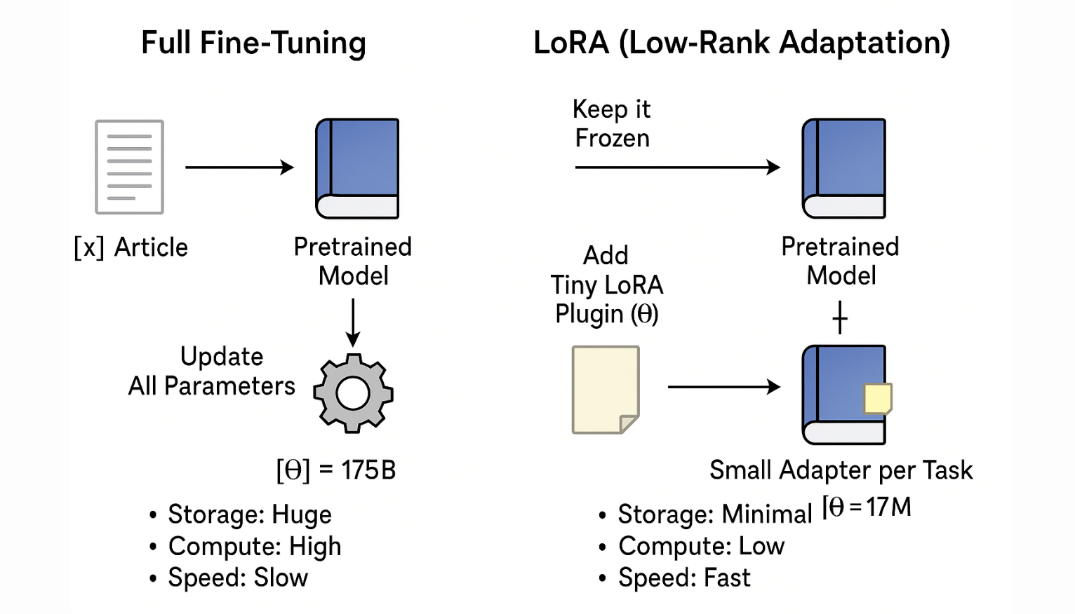

In practice for multimodal → many people apply LoRA only to the projector or the LLM part, keeping the frozen vision encoder. Your fashion app can fine-tune on Odisha-specific saree styles (Pochampally ikat, Sambalpuri motifs) with just a laptop GPU overnight.
- Preference Tuning Concepts (DPO, RLHF-style): After basic fine-tuning, rank responses: "Helpful + accurate > helpful but hallucinated > rude/unhelpful". Train the model to prefer grounded, truthful answers.
Why it matters for groundedness → Without it, models confidently invent details ("this saree is pure silk" when it's actually polyester blend). Preference tuning teaches "only say what you see" huge for e-commerce trust.

Data Curation for Multimodal: Garbage In = Garbage Out
Multimodal data is messy – internet photos come with noisy captions, bad OCR, weird tables. Curation is 80% of the battle.
Common pain points:
- Caption noise: "beautiful woman in dress" attached to a saree photo → model learns wrong associations.
- OCR noise: Scanned invoices or labels misread ("Total: $100" read as "Tota1: $1OO").
- Chart/table labeling issues: A pricing table screenshot gets caption "some numbers" → model never learns to read rows/columns properly.
Practical curation steps people use:
- Filter by CLIP score (image-text similarity > 0.28 or so).
- Run dedicated OCR models (like TrOCR) and verify.
- Use synthetic data: Generate clean table images with known labels.
- Human-in-the-loop for high-value domains (medical, legal, fashion authenticity).
In your app → curate a small high-quality set of 5,000 saree photos with accurate descriptions ("pure silk, handwoven, blue with gold zari border, 6.5m length") instead of 500k noisy ones. Quality wins.
Real-World Example: Datasets like LAION-5B use CLIP filtering to curate billions of image-text pairs for training stable diffusion models.
Code Implementation Example: Simple CLIP score filtering (using pseudo-CLIP).
import torch

def clip_score(image_emb, text_emb):
# Assume normalized embeddings
return torch.dot(image_emb, text_emb).item()

# Example: filter if score > 0.28
img_emb = torch.randn(512)
txt_emb = torch.randn(512)
score = clip_score(img_emb, txt_emb)
if score > 0.28:
print("Keep pair")
else:
print("Discard")

Evaluation Traps
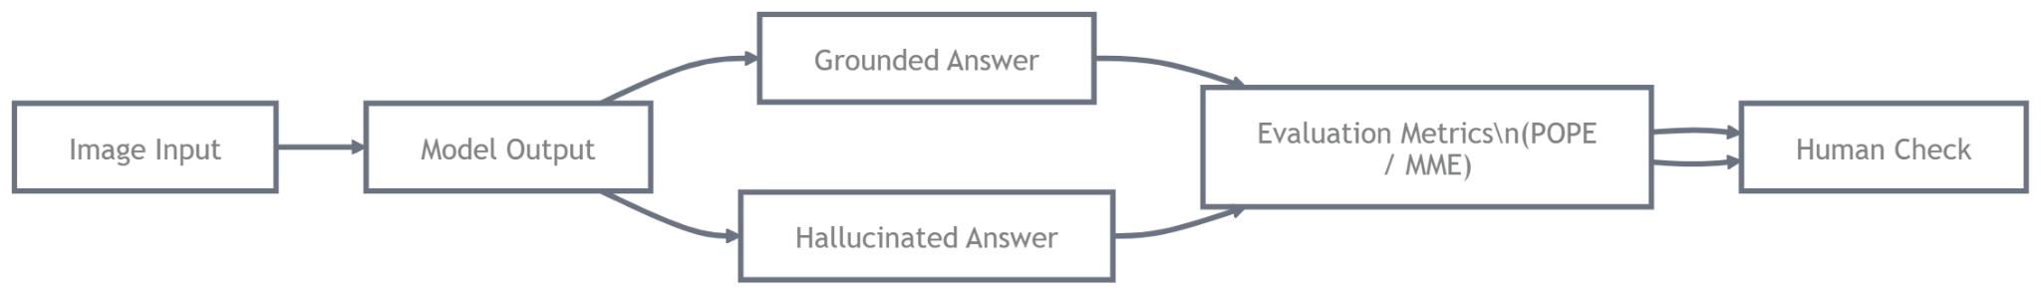
This is the sneaky part – models can sound fluent and plausible but be completely wrong about the actual image.
Classic traps:
- Looks correct but hallucinates: "The woman is wearing a red saree with heavy embroidery" when the photo shows blue plain cotton.
- Groundedness failure: Model ignores the image and just parrots training data bias.
A great diagram showing how hallucinations creep in across modalities (text trusts image → but image details get lost):
​​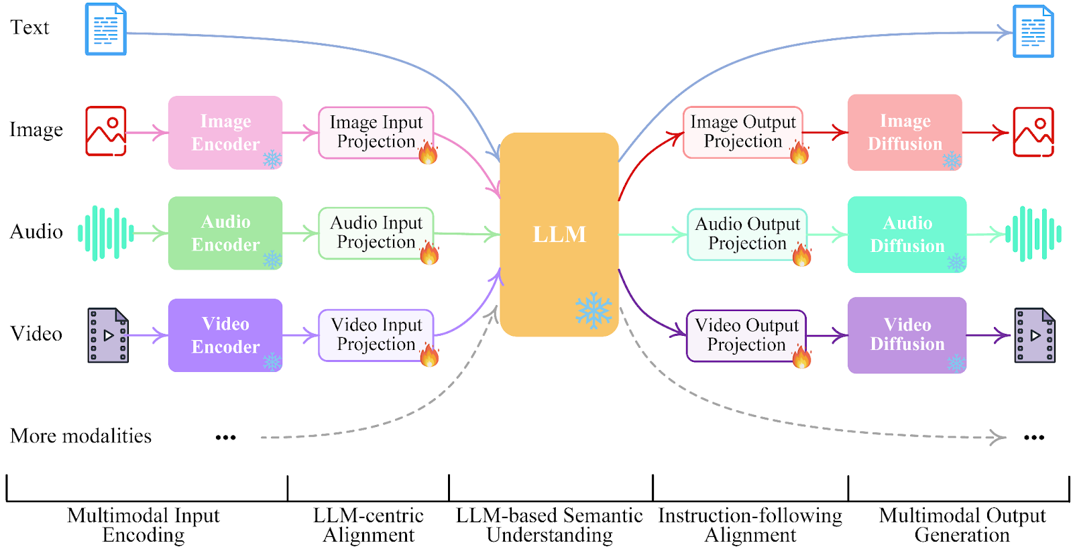

And this one visualizes grounded chain-of-thought – model points to exact regions it used for reasoning:
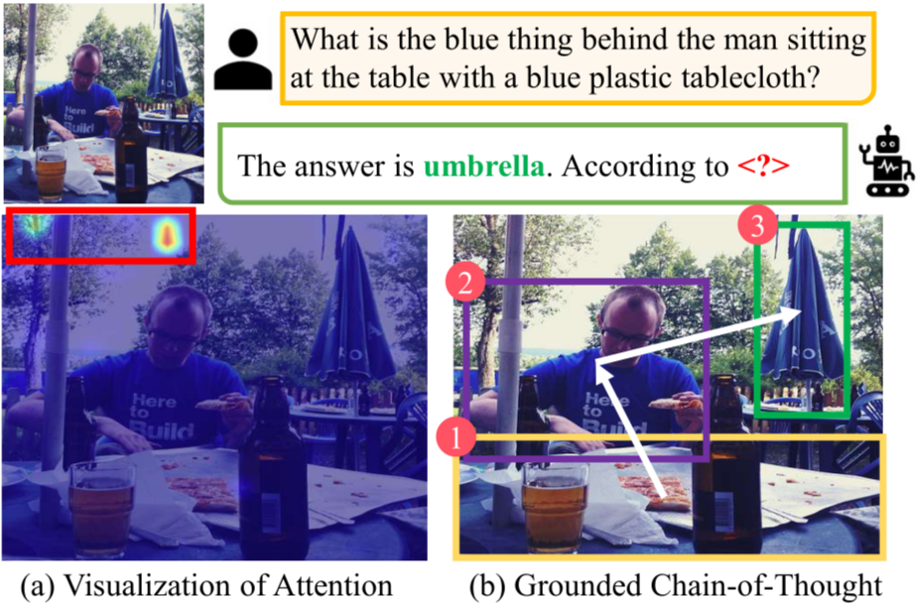

How to catch it practically:
- Use metrics like POPE (Polling-based Object Probing & Existence) or MME (Multimodal Evaluation benchmark).
- Human eval with "Does the answer strictly follow what's visible?"
- Visual grounding checks: Ask model to highlight bounding boxes for claims.
In fashion app → if a customer uploads a damaged saree photo for return, the model must ground its "tear on the border" claim to the actual spot – not just say "damaged" generically. Grounded = trustworthy = fewer disputes.
Real-World Example: Benchmarks like VQA (Visual Question Answering) evaluate models on grounding, used by companies like Meta for LLaMA-based VLMs.
Code Implementation Example: Simple grounding check (pseudo-code for bounding box alignment).
def grounding_score(pred_boxes, gt_boxes):
# Intersection over Union (IoU) for boxes
iou = [] # Compute IoU for each pair
for pred, gt in zip(pred_boxes, gt_boxes):
inter = max(0, min(pred[2], gt[2]) - max(pred[0], gt[0])) * max(0, min(pred[3], gt[3]) - max(pred[1], gt[1]))
union = (pred[2] - pred[0]) * (pred[3] - pred[1]) + (gt[2] - gt[0]) * (gt[3] - gt[1]) - inter
iou.append(inter / union if union > 0 else 0)
return sum(iou) / len(iou)

# Example: [x1,y1,x2,y2]
pred = [[10,10,50,50]]
gt = [[15,15,55,55]]
score = grounding_score(pred, gt)
print(score) # High if grounded

Conclusion & Key Takeaways
Pretraining signals lay the multimodal foundation, while fine-tuning and curation ensure practical, grounded performance. Avoid evaluation traps to build reliable systems.

Key Takeaways
- Contrastive (CLIP) dominates for alignment/zero-shot; mix with captioning/masking/multi-task for depth.
- LoRA/Adapters enable efficient fine-tuning (~1% params); apply to projector/LLM for multimodal.
- Preference Tuning (DPO/RLHF) combats hallucinations for trustworthiness.
- Data Curation: Prioritize quality (CLIP filtering, OCR) over quantity.
- Evaluation: Focus on grounding (POPE/MME, human checks) to catch fluent but wrong outputs.
- In apps like fashion: Pretrain for matching, fine-tune for Odisha styles, evaluate for accurate descriptions → boost sales/trust.

